Project Requirement Document[PRD]

Client Background
The client is an educational consulting organization operating across Tamil Nadu. They provide guidance to students and parents in selecting suitable colleges based on multiple factors such as placement performance, infrastructure quality, affordability, and academic environment.
Currently, their recommendations are largely based on manual evaluation and individual experience, which leads to inconsistencies and lack of scalability.

Problem Statement
The client has shared a dataset containing approximately 500 colleges across Tamil Nadu, along with multiple quantitative attributes for each institution.
However, the dataset does not contain any predefined categorization such as “Best”, “Mid-Level”, or “Emerging” colleges.
The client wants to:
- Identify natural groupings of colleges based on performance and infrastructure metrics
- Avoid human bias in classification
- Build a data-driven segmentation system

Dataset Description
The dataset contains the following features:
- College_Name: Name of the college (non-numerical, identifier)
- Student_Faculty_Ratio: Number of students per faculty
- Annual_Fees_INR: Annual tuition fee (in INR)
- Placement_Percentage: Percentage of students placed
- Average_Package_LPA: Average salary package offered (in LPA)
- Infrastructure_Score: Rating of infrastructure (scale-based between1 to 10)
All features except the college name are numerical.

Key Challenges
- No predefined labels (unsupervised problem)
- Features are in different units (scale imbalance)
- Some colleges may perform well in certain aspects but not others
- Manual classification is not feasible at scale

Expected Deliverables
- Clustered dataset with category labels
- Dendrogram visualization
- Explanation of cluster characteristics
- (Optional) Predictive model for future classification

Business Impact
- Helps students make informed decisions
- Reduces dependency on manual judgment
- Provides scalable and consistent recommendations
- Enables data-driven educational consulting

Client Expectation
The client expects a clear explanation of:
- How clustering works
- Why certain colleges fall into specific categories
- How this system can be extended for future predictions

Final Note
The client emphasizes that:
“We are not looking for a predefined ranking system
we want the data to reveal the categories naturally.”

Regards,
AI Coach John
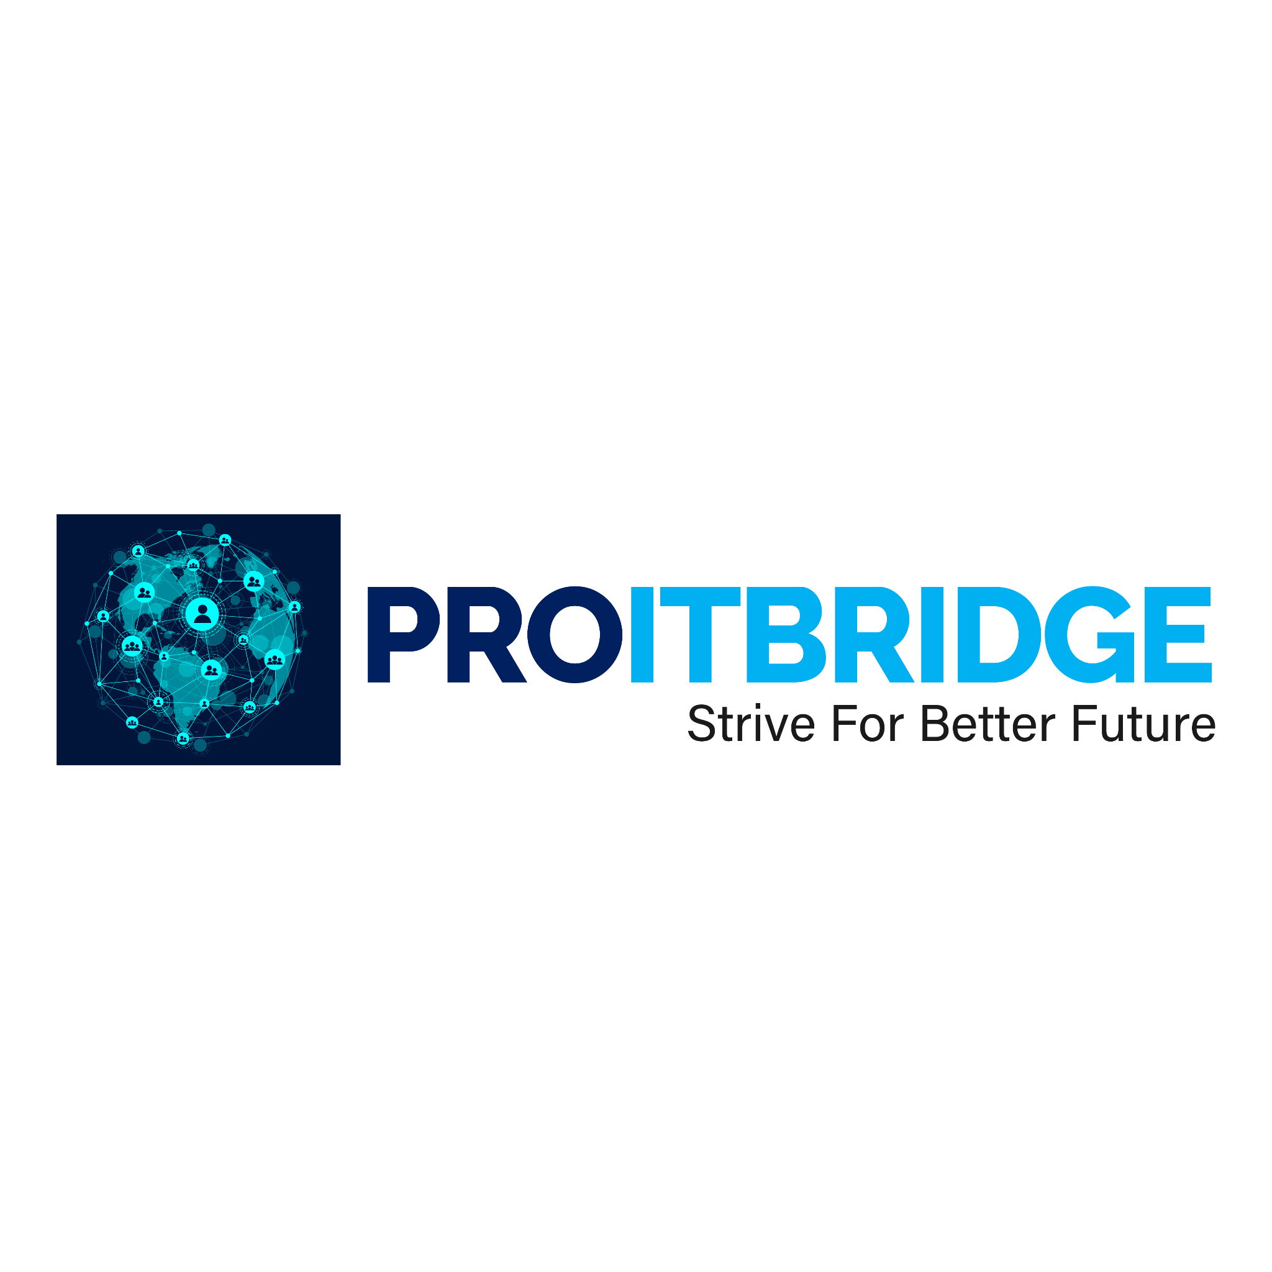
CEO & Founder of ProITbridge.
Youtube: https://www.youtube.com/@aicoachjohn
LinkedIN:https://www.linkedin.com/in/aicoachjohn/
Instagram: https://www.instagram.com/john_the_ai_coach/
Website: https://www.proitbridge.com/

